Programming Assignment 2: Trajectory Optimization
The assignment release folder: https://drive.google.com/drive/u/0/folders/1c1zVzG0iQ6hB4SS7enAhaRa4VSsjsWZF
All assignment materials are stored here.

Summary:
The assignment instructions are included in the notebook. This document covers installation instructions. Note that the assignment contains code sections that you will fill in, as well as some reflection questions. Write your answers in text cells in the notebook.

Setup and Installation:
The notebook requires a particular Colabs runtime environment. This should be configured automatically if you open the notebook via the link below. We have also included instructions to set up the environment manually, in case this fails for any reason.

The Easier Way
- Open the Colabs notebook here: https://drive.google.com/file/d/1MmPhLG5VNAVxYwsW1EevQ5qdHh1MF2QU/view?usp=drive_link You will only be able to view the notebook.
- Create a copy of the notebook in your Google Drive with File>Create a Copy in Drive. You will add your work to this copy.
- The first time the notebook opens in a new tab or browser it will install Numpy 1.25 (for compatibility with GTSAM). This requires the default Numpy 2.2 to be uninstalled. This will all happen automatically, but it will take up to around a minute and you will see the following dialogue: 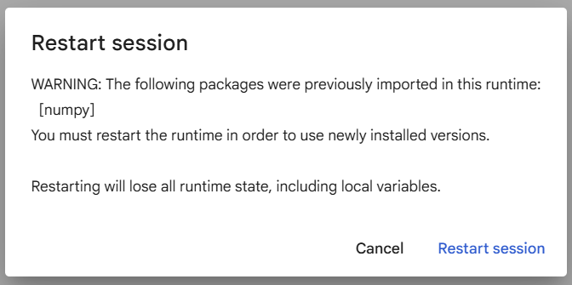Select “Restart Session”
- You should now be able to run the assignment normally. Select run all to check that the first code block with the import statements runs correctly. If you have any trouble please notify the TA’s.

The More Complicated Way
- To change the Colabs runtime environment you can click the bottom corner of the display where it says “Python 3” 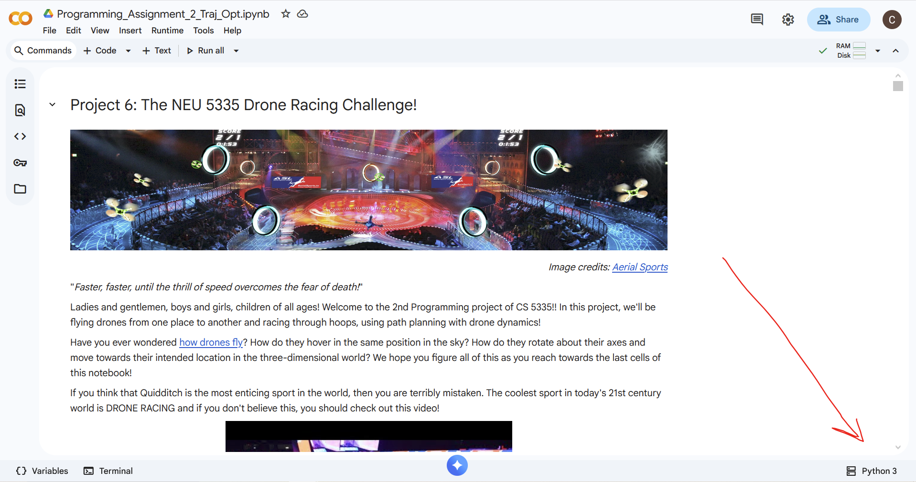
- Select “Change Runtime Type”
- Change the runtime version at the bottom of the menu to “2025.07”. Leave other fields at default settings.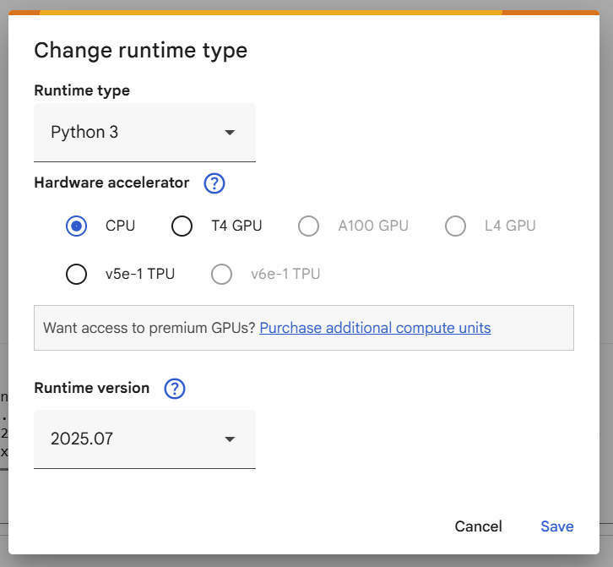
- Proceed with step 3 of “The Easier Way”

Helpers
The assignment uses a set of helper functions for visualization, drone kinematics, etc. The file containing these functions should be downloaded automatically by the following code lines:
!pip install --upgrade --no-cache-dir gdown &> /dev/null
!gdown 1Lrz8hLUugzudsN1kd9baK1cQ-CC2SKnJ
If there is any problem with this, the file can be manually uploaded by dragging and dropping it to the files tab at the left of the Colabs window:
